Guidance for Online Printing of Transcripts and CertificationS
1.Entry Methods  Method 1: Use WeChat search to enter the small program "校务行 " | Method 2: Scan the QR code below to enter the small program "校务行"
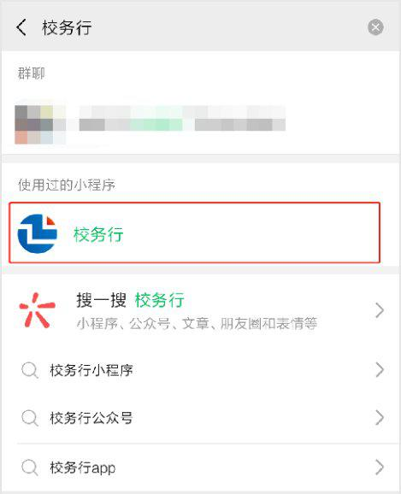
Open the "校务行"applet and select "Zhejiang University of Science and Technology". The account number is your student ID and the password is the your passport number. If you encounter login problems, click "Contact Customer Service", leave your "name + student number + school + encounter Problems", a customer service staff will contact you later.
2.Electronic transcript & certificate
After logging in, click on the electronic transcript or electronic certificate, select the required file type, and generate a preview.Electronic transcripts include: highest transcript in Chinese, highest transcript in English, full English transcript, full Chinese transcript, etc.Electronic proof documents include: Proof of Study , Pre-graduation Certificate etc.
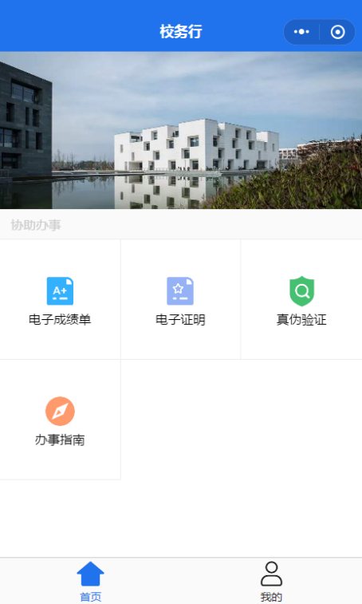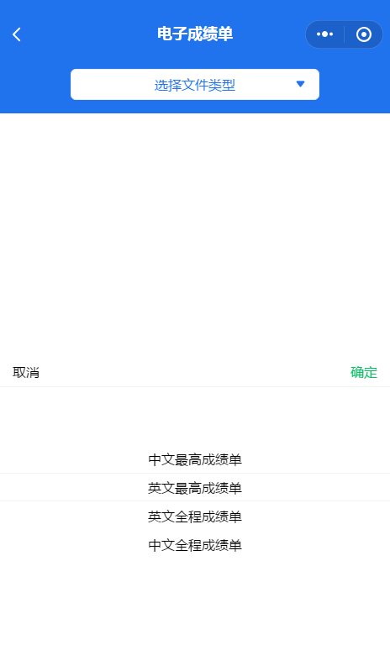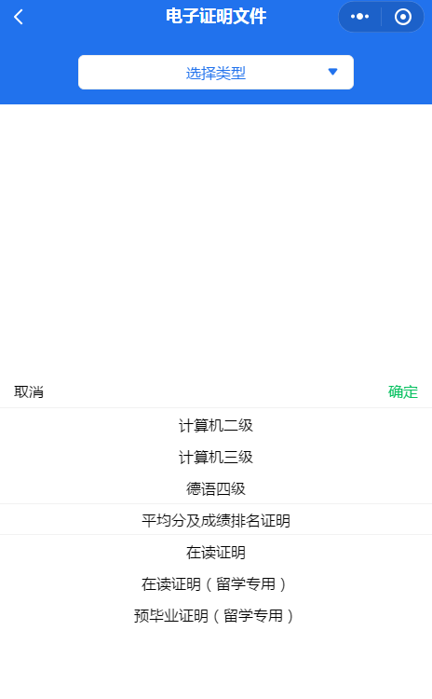
-Main interface- -Electronic score certificate- -Electronic certificate-

Generate a preview image, pay attention to check for errors and fill out your personal mailbox. After paying network resource service fees, you can print electronic transcripts and certification documents during the epidemic. If you do not receive anything in your mailbox, you can resend it in the application record. If you encounter problems, you can contact customer service at the fifth point below.
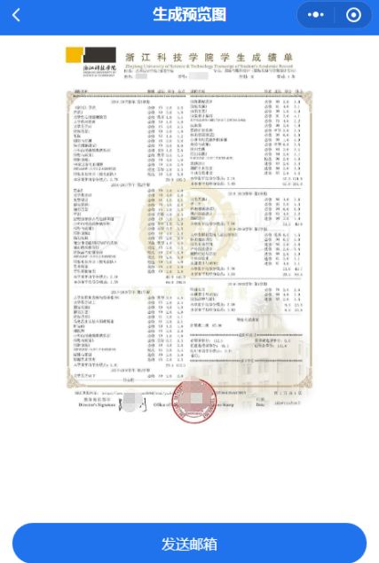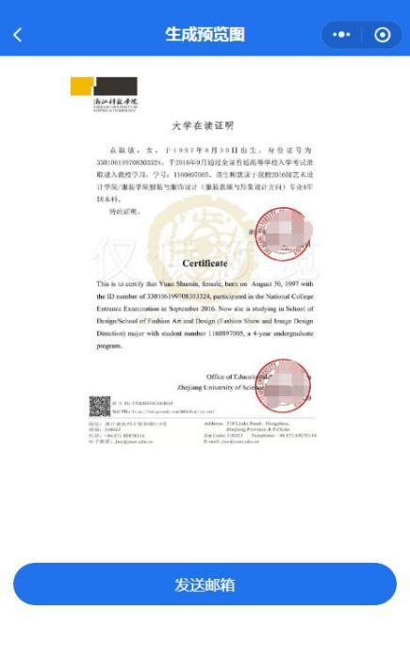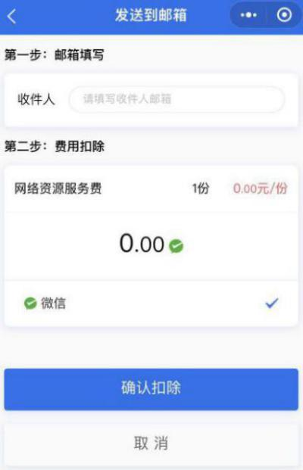
-Electronic transcript preview- -Preview of electronic certificate- -Fill in the mailbox--

Electronic transcripts and proof documents can be previewed online anytime, anywhere, and the type you want to print can be customized. It can be sent to the student’s personal or third-party organization’s mailbox by email. The paper version can be printed on the student self-service printing terminal. Or you can bring the electronic version to the print shop to print.
3. Mail View
After sending it to the mailbox, the following information will be presented. Click on the attachment to download, and there is a unique authenticity certification on the file to ensure the authenticity. There may be problems such as format incompatibility when previewing on the mobile phone. All are subject to computer preview. If you encounter problems, please submit feedback.
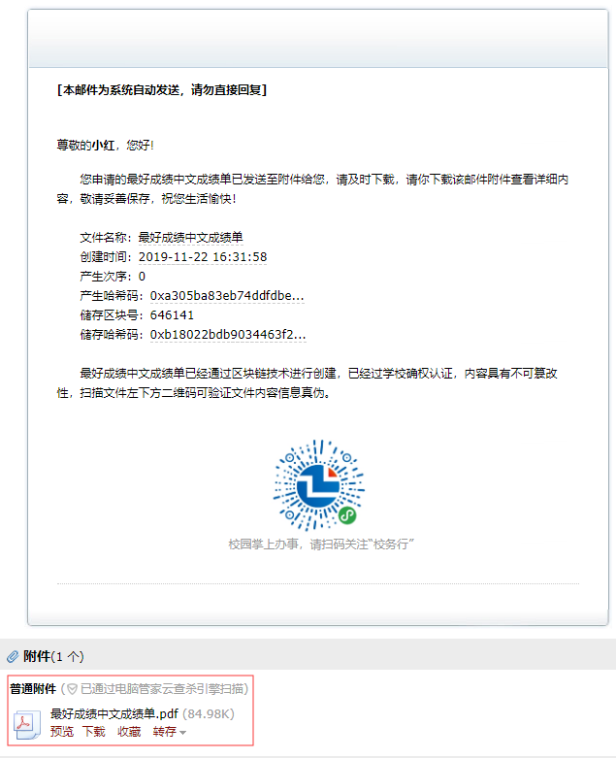
Click the attachment to download
Email details

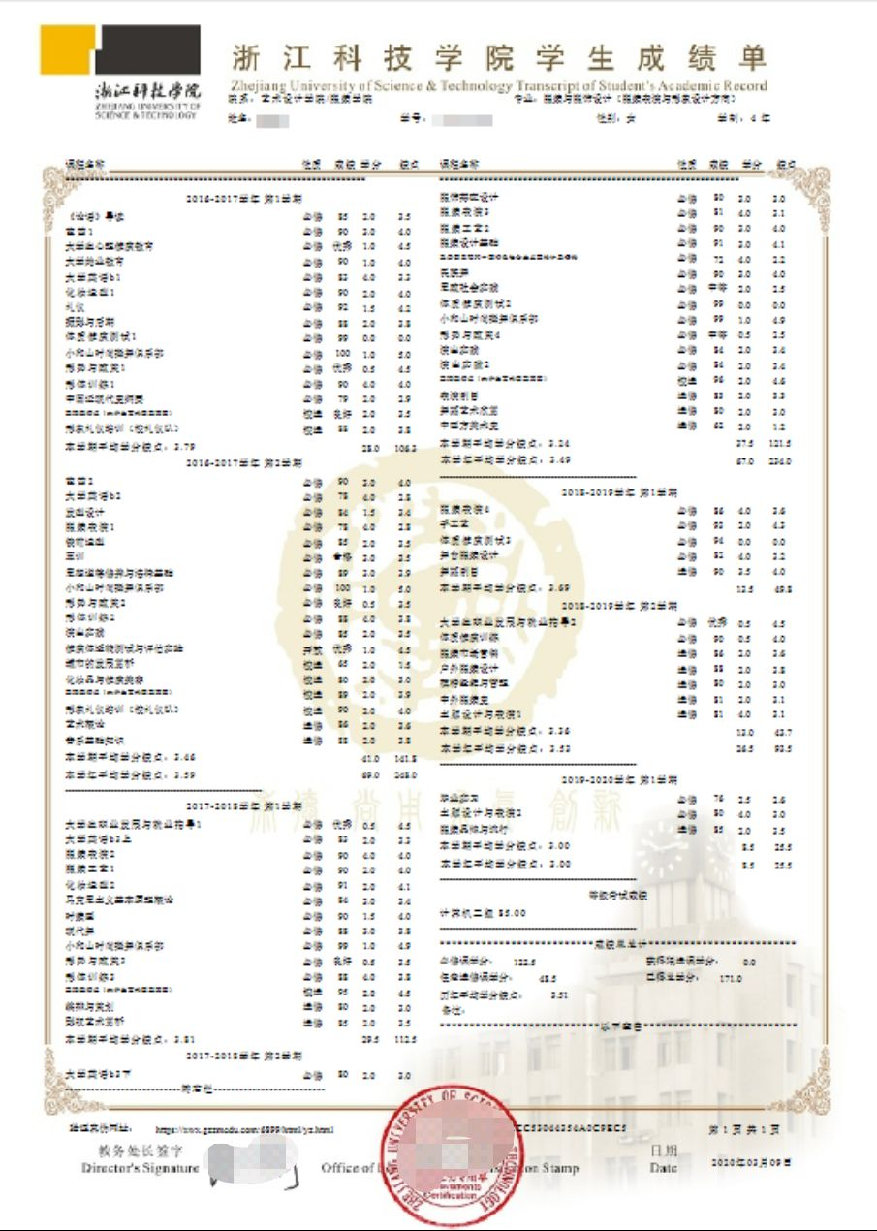
Transcript

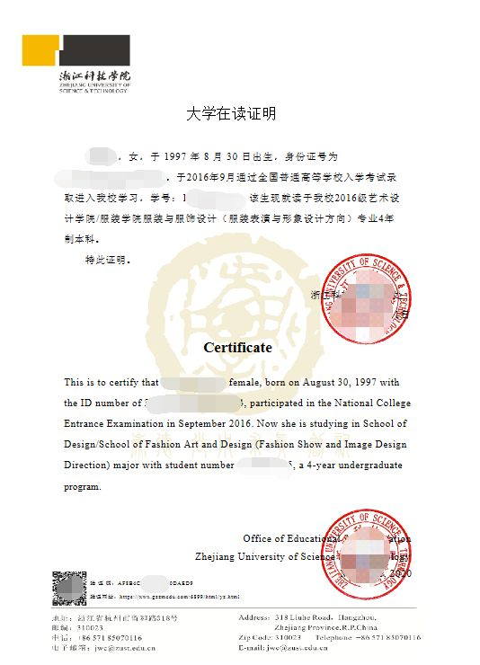
certified documents
Reminders
1. Preview before downloading and then download after checking.
2. It is recommended to open the computer after downloading, some mobile phone mailbox direct preview may have format incompatibility.
3. There is a special electronic seal signature inside the document. The content of the document cannot be changed at will, otherwise the document is invalid.
4. The above file downloads are allowed to be free during the epidemic.
5. When contacting customer service, you need to leave your "name + student number + school + problems encountered".

